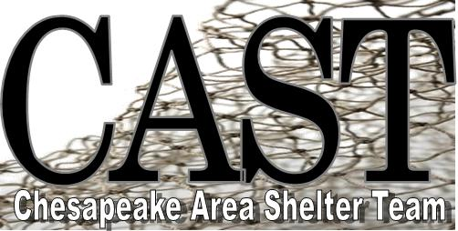
CAST serves the homeless in Chesapeake: Emergency Winter Shelter Program and Burfoot House: Program for Homeless Women (renovations underway).

Emergency overnight winter shelter program opens November 9, 2016.

* One intake location is at 7:00 pm at 1209 20th Street, Chesapeake, 23324 (parking lot across from police precinct)
* 49 homeless guests accepted with ID (serve men, women and families)
* Homeless with cars welcomed, but must meet nightly at intake location.
* No alcohol, no drugs, no weapons
* Breathalyzer screening
* No sex offenders (database checked)
* Smoking is at the discretion of the host church
* No pets
* 7:30 pm arrival at the host church temporary emergency shelter. There is another ID check-in at registration, dinner, optional activities, fellowship, case management helps few nights a week, sleeping is on 2" mat and blanket on fellowship hall floor area that is supervised, breakfast at 6:00 am, and bus departs at 6:30 am back to intake location.
* The Self Sufficiency Center is open Wednesdays from 11 am - 3 pm at 1st Presbyterian Church South Norfolk offering resume, interview & computer helps, job leads, mentorships, and open art studio. The Burfoot House is being renovated and will serve homeless women.
Call (757) 321-9353
@chesapeakeareashelterteam
Message Now

cast@gbpres.org
http://www.abbalist.org/

